Math 1309- Spring 2012
Review for Exam #3

Topics for Exam #3
- Anti-derivatives and Indefinite Integrals
- Integration by substitution
- Area under the curve and definite integrals
- Area between curves (using a graphic calculator)
- Simple and compound interest, APY
- Present value of annuities
- Future value of annuities

Review Exercises.
1. Find the indicated indefinite integrals.
a)*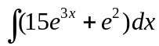 b) 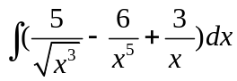 c)* 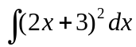 d)*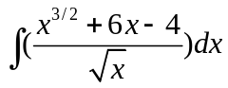
e) 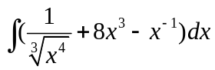
a) 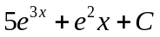 b) 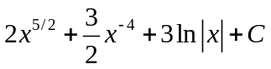 c) 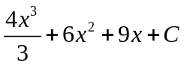 d) 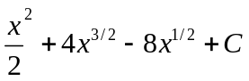
e) 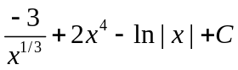

2. Find the solution to each of the given initial value problems (i.e. find a function with the given derivative and that satisfies the indicated initial condition)
a) 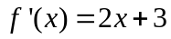 and 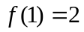 b)* 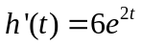 and 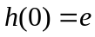 c)*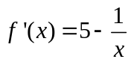 and 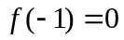
a) 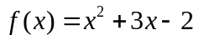 b) 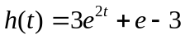 c) 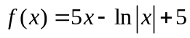

3. Use the method of substitution to find the following indefinite integrals
a)*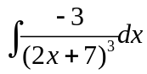 b) *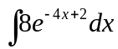 c) 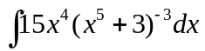 d)*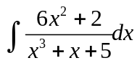 e)*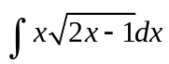
f)*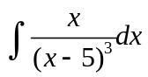
a) 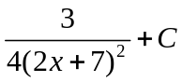 b) 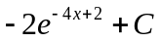 c) 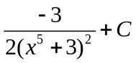 d) 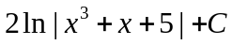
e) 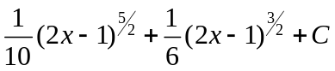 f) 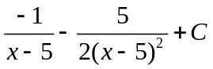

4. Do problems 69*, 70*, 74, and 81 in section 13.2

5. Evaluate each definite integral (Hint: use substitution for the last three problems). DO NOT INTEGRATE IN YOUR CALCULATOR
a) 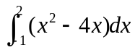 b)* 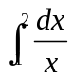 c)* 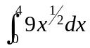 d)* 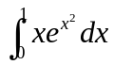 e)*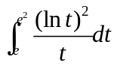 g)* 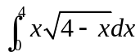
a) -3 ; b) 0.69 ; c) 48 ; d) 0.86 ; e) 2.33 ; f) 8.53

6. Determine the area of the specified region. Draw a graph of the functions and shade the appropriate region. CALCULATOR IS ALLOWED to integrate but you must write down the integral that you evaluated

a)*Area under 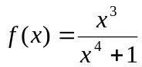 between x= -1 and x=4
b) *Area under 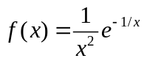 between x=1/2 and x=2
c) Region bounded by 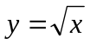and  between x = 0 and x = 2
d) Region bounded by 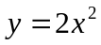 and 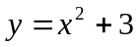

a) 1.214 b) .471

7. Do problems 63*, 64*, and *67 in section 13.5

8. Solve the following word problems, write all your answers in complete sentence and include appropriate units
- In order to accumulate enough for a down payment on a house, a couple deposits $300 per month into an account paying 6% compounded monthly with payments made at the end of each period. How much money will be in the account in 5 years?
- A company offers an annuity that pays 6.35% compounded quarterly. What quarterly payments will have to be done in order to have $200,000 in 15 years?
- A company estimates that they will need $1,500,000 in 8 years to replace some equipment. If the company establishes a sinking fund by making fixed monthly payments into an account paying 7.8% compounded monthly, how much would each payment be?
- You plan to deposit $200 every month into an account that pays 6.6% compounded monthly. How long will it be before the account has $100,000? How much money will you actually deposit into the account in all those years?
- Instead of depositing the $200 monthly as in problem (d) you want to deposit P dollars now at 6.6% compounded monthly and get the $100,000 in the same amount of time found in (d). How much do you need to deposit now?
Compare your answers to (d) and (e). What would give you a better return for your money?
- You need to ask for a loan to buy a car. The two banks that you approached offer you the following plans
Bank A: 13.2% interest compounded semiannually
Bank B: 12.9% interest compounded monthly
Which loan would be a better deal?
- Find the APY for money invested at 96% compounded semiannually, 9.5% compounded weekly, and 9% compounded continuously. What would be the best investment?
- A couple of new parents deposits $10,000 in a certificate of deposit the day their daughter is born. If the account pays 4.5% compounded continuously, how much money will there be in the account the day that the daughter turns 18 years old?
- Assume that annual inflation is 3% (and will stay at that level for the next ten years). What will be the price of a half-a-million house in 10 years? (Assume simple interest)
- What is the annual interest rate if an investment of $5,000 compounded monthly doubles it’s value in 6 years?

a) They will have about $20,930 in 5 years
b) Payments will have to be $2,019 (rounded to the nearest dollar)
c) Monthly payments will be $11,303 (rounded to the nearest dollar)
d) I t will take about 20 years to reach $100,000
e) You need to deposit about $26,322
f) Bank A has and APY of 13.64% and bank B has an APY of 13.69%. Bank A is a better deal for a loan
g) APY in each case is 9.83%, 9.96%, and 9.41%. The best deal for an investment is 9.5% compounded
weekly

